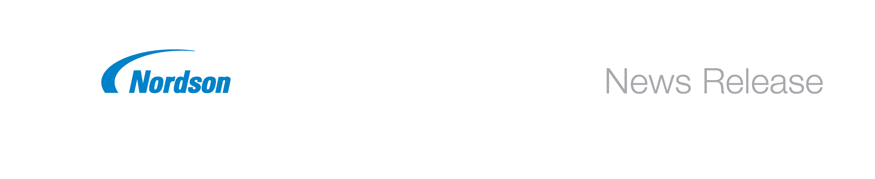
FOR RELEASE: Immediately
CONTACT: Elizabeth Jordan
770.497.3425
ejordan@nordson.com

Nordson Corporation
11475 Lakefield Drive
Duluth, Georgia, 30097 USA

Nordson VersaPUR Adhesive Melters Simplify Use of Reactive Polyurethane Adhesives

Duluth, Georgia, USA – February 18, 2014 – Nordson Corporation (Nasdaq: NDSN) has released VersaPUR™ adhesive tank melters as its latest moisture-curing reactive polyurethane (PUR) adhesive system to facilitate and enable PUR adhesive use in manufacturing. The VersaPUR tank melter simplifies processing, clean-up and maintenance of moisture-curing reactive hot melt adhesive with a unique “easy-to-clean” design. VersaPUR melters are ideal for use in a wide variety of assembly applications including edgebanding, profile wrapping, bookbinding and automotive subassembly.

Smooth, non-stick release coated surfaces and a tiltable tank provide easy access for cleanup and maintenance. And, all components in contact with PUR offer easy access and quick disassembly to facilitate cleaning. User-friendly, intuitive graphic controls simplify programming and provide visibility of system status.

VersaPUR adhesive tank melters feature:
- Easy-to-clean design and non-stick coated surfaces to simplify maintenance and operation.
- Graphical touch-screen controls to simplify programming and system monitoring.
- Intuitive melter control of relevant functions via Industrial PC.
- Optional sensor and warning for tank level.
- Integrated or external inert gas supply to produce inert gas blanket.
- A variety of precision, variable-speed gear pump options, with key-to-line availability.
- A choice of manual or automatic pressure controls.

For more information about Nordson’s VersaPUR adhesive tank melters or any of our PUR dispensing solutions, contact Nordson toll-free at (800) 683-2314 or visit www.nordson.com/adhesive.
Nordson engineers, manufactures and markets differentiated products and systems used for dispensing and processing adhesives, coatings, plastics, sealants and biomaterials, with related technologies for managing fluids, testing and inspecting for quality, and treating surfaces. These products are supported with extensive application expertise and direct global sales and service. The company serves a wide variety of consumer non-durable, durable and technology end markets including packaging, nonwovens, electronics, medical, appliances, energy, transportation, construction, and general product assembly and finishing. Founded in 1954 and headquartered in Westlake, Ohio, the company has operations and support offices in more than 30 countries. Visit Nordson on the web at www.nordson.com, www.facebook.com/nordson, or @Nordson_Corp.
Photo: Nordson VersaPUR Tank Melter

NNR: 1402

Follow us on LinkedIn
Follow us on Twitter
Like us on Facebook
Visit us on YouTube

